Proposal Seminar Invitation of PNBP LPPM of 2020

By: Chalid Luneto. April 3, 2020. 12:38:00

Related to the implementation of the research fund by the Non-Tax State Revenue/Public Service Agency UNG 2020 at the Research and Community Service Office (LPPM) Universitas Negeri Gorontalo, it is hereby notified that LPPM will hold a Research Proposal Seminar for lecturers who have proposed their proposals. By considering the Circular of the Rector of UNG to anticipate current conditions and prevent crowds, the following things need to be considered:

1. The seminar will be held online through web conference video application

2. Make sure the device to be used at the seminar is a laptop, cell phone/tablet equipped with the latest updated browser (google chrome, Mozilla, Opera, etc.) and a stable internet connection

3. The seminar will be held from Monday to Thursday, April 6 – 9, 2020 (Schedule Attached)

4. Seminar participants are expected to have entered the conference web application at least 15 minutes before the presentation schedule

5. The presentation was conducted for 10 minutes (5 minutes of presentation and 5 minutes of question and answer)

6. Other provisions will be communicated later on the information media available for that purpose.

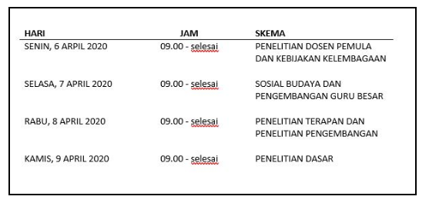

|  |  |  |
| --- | --- | --- |
| Day | Time | Scheme |
| Monday, April 6, 2020 | 09.00 – finish | NOVICE LECTURER RESEARCH AND INSTITUTIONAL POLICY |
| Tuesday, April 7, 2020 | 09.00 – finish | NOVICE LECTURER RESEARCH AND INSTITUTIONAL POLICY |
| Wednesday, April 8, 2020 | 09.00 – finish | APPLIED RESEARCH AND DEVELOPMENT RESEARCH |
| Thursday, April 9, 2020 | 09.00 – finish | BASIC RESEARCH |

LPPM